Coordinate Graphing System
The coordinate graphing system is formed by a pair of perpendicular number lines. The two lines intersect, or cross, to form four right angles.
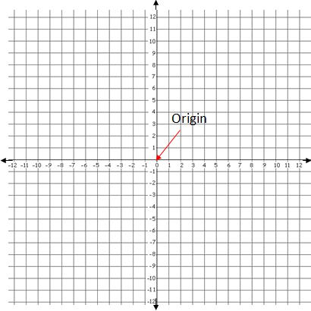 | The number lines are both marked with the set of integers. They intersect each other through zero on each line. This intersection point is called the Origin.
Perpendicular Lines are lines that cross to form four right (90º) angles.  Number lines are lines which have been divided into equal parts which are numbered at regular intervals, in the same way as a ruler is divided and marked.  Integers are all the positive whole numbers, their opposites (the negative values of each number), and zero. | Vocab.
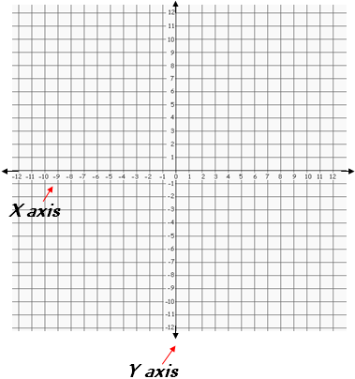 | Each of the two number lines is called an axis (pronounced "ack-sis"). The plural form of axis is axes (pronounced"ack - sees").  The horizontal axis, the one that goes across from side to side, is called the X axis.  The vertical axis, the one that goes up and down, is called the Y axis.
Points can be drawn, or plotted, on the coordinate graph using specific coordinates. These coordinates are written using an ordered pair of numbers. These numbers are written inside parentheses and are separated by a comma.
A point is always plotted from the starting point of the origin, where the lines intersect through the number zero. The first number in the ordered pair shows how far left or right to move from zero on the x axis. The second number in the ordered pair shows how far up or down to move from zero on the y axis.
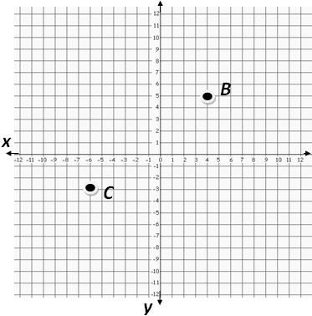 | The coordinates of point B are (4,5) because it is located 4 units to the right of zero on the x axis, and 5 unit up from zero on the y axis. It is plotted where the two lines cross.  The coordinates of point C are (-6, -3) because it is located 6 units to the left of zero on the x axis, and 3 units down from zero on the y axis. It is plotted where the two lines cross.

Graph Quadrants
If you look at the coordinate graph, you can see that when the x and y axes cross, they form four sections. These sections are called quadrants. That's why you will sometimes hear a coordinate graph be called a four-quadrant graph. The quadrants are numbered using Roman numerals, starting with the top right quadrant, and moving around in a circle to the left.
The quadrant the plotted points will fall in depends upon whether the numbers in the ordered pair are positive or negative integers.  If both the x and the y number are positive, the point will be in quadrant I. If the x number is negative, but the y number is positive, the point will be in quadrant II. If the x and y numbers are both negative, the point will be in quadrant III. If the x number is positive, but the y number is negative, the point will be in quadrant IV. | 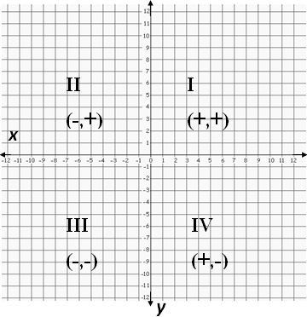
1. What kind of lines form a coordinate graphing system?
Perpendicular lines form the coordinate graphing system.
2. What is the vertical line called?
The y axis
3. What is the horizontal line called
The x axis
4. How do you know whether to go right or left from zero on the x axis?
If the x number is positive, go right. If it is negative, go left.
5. What are the numbers that give the coordinates of a point called?
The coordinates of a point are called an ordered pair.

Recap
- The coordinate graphing system is formed by the intersection of two perpendicular number lines marked by integers.
- The lines are called the x and y axes.
- The x axis is horizontal.
- The y axis is vertical.
- The origin is the point at which the lines intersect.
- The intersecting lines form four sections, called quadrants, numbered with Roman numerals.
- The coordinates are written as an ordered pair.
- The ordered pair is always written in the (x, y) format.
- Always begin at the origin when plotting a point.

