Quadrilateral Properties and Hierarchy
Follow the arrows down (or up if your prefer) the table to view the various categories and sub-categories.
Square
A Square is a quadrilateral with equal-length sides forming four right-angles.
A square is  also a special type  of |  | ... and it is  also a special type  of
Rhombus |  | Rectangle
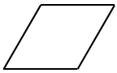  A Rhombus is a Quadrilateral in which opposite sides are parallel and all four sides are of equal length. |  | A rectangle is a quadrilateral with four right-angles and opposite sides that are parallel.
A Rhombus is also  a special type  of | ... and it is also  a special type  of | A Rectangle is also  a special type  of
Kite | Parallelogram
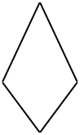  A Kite is a Quadrilateral in which the sides can be grouped into two pairs of adjacent equal-length sides. | A Parallelogram is a quadrilateral in which each of the two pairs of opposite sides are parallel.
A Parallelogram is also
a special type
of
 | Trapezoid
 | A Trapezoid is a Quadrilateral in which two of the sides are parallel.
A Kite is also  a special type  of | A Trapezoid is also  a special type  of
Quadrilateral
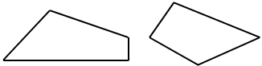
A Quadrilateral is a polygon with four sides.

