VOLUME
Volume measures how much space an object occupies. Sometimes you might hear questions like "what is the capacity of a box?" or "how much can the box hold?" You can assume that these questions will need a volume to be calculated.

Calculating Volume
Volume is measured in cubes (or cubic units).
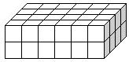
How many cubes are in this rectangular prism (cuboid)?
We can count the cubes although it is quicker to take the length, width, and height and use multiplication. The rectangular prism above has an volume of 48 cubic units.
The volume of a rectangular prism is = length x width x height

Examples of calculating the area of a rectangle
We need to do two multiplications to work out the volume. We calculate the area of one face (or side) and multiply that by its height. The examples below show how there are three ways of doing this.
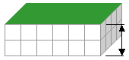 | Area = 6 x 4 = 24  Volume = Area x 2  Volume = 24 x 2 = 48 cubic units
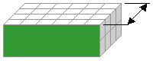 | Area = 6 x 2 = 12  Volume = Area x 4  Volume = 12 x 4 = 48 cubic units
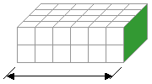 | Area = 4 x 2 = 8  Volume = Area x 6  Volume = 8 x 6 = 48 cubic units
Notice how we get the same answer no matter what side we use to find an area.

Units for measuring volume
There are very big differences between units of measure for volume. For example, there are 100 centimeters in 1 meter but there are 1,000,000 (yes, 1 million) cubic centimeters in a cubic meter.
Why the big difference? Because in volume we have not just length; we have length, width, and height. The sugar cube example below shows this.
How much sugar? 1 m³ or 1,000,000 cm³
Think of filling a very big box (it would be 1 meter wide, 1 meter, long, and one meter high) with sugar cubes (with each side 1 centimeter).
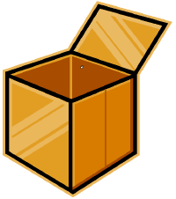 | Step 1: one row along the bottom of the box - that would be 100 sugar cubes
 | Step 2: cover the rest of the base of the box - that would give a total of 100 rows each with 100 sugar cubes. 100 x 100 = 10,000 sugar cubes at the bottom of the big box.
 | Step 3: Repeat this 99 times until there are layers of 10,000 cubes stacked 100 deep. 10,000 x 100 = 1,000,000 sugar cubes
There are 1,000,000 cm³ in 1 m³ - be careful not to have too much sugar!
There are other units for measuring volume; cubic inches, cubic feet, cubic yards are all units used for measuring volume. Milliliters, liters, gallons are also used especially when measuring liquids.

Don't forget the wee 3
We write cubic sizes using a small ³ next to the unit.
We write mm³, cm³, m³ , km³, cm³
We can say "85 centimeters cubed" or "85 cubic centimeters"

Examples of Calculating Volume of Rectangular Prisms
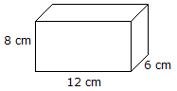 | Volume = Length x Width x Height  Volume = 12 cm x 8 cm x 6 cm  = 576 cm³
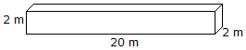 | Volume = Length x Width x Height  Volume = 20 m x 2 m x 2 m  = 80 m³
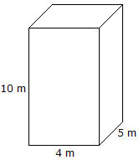 | Volume = Length x Width x Height  Volume = 10 m x 4 m x 5 m  = 200 m³

